Fire Weather Index Predictor
[A Machine Learning Model to Predict Fire Weather Index]



Infosys SpringBoard Virtual Internship Program

Submitted by
U P Mahendra
Under the guidance of Mentor Praveen

Project Statement
Project Statement: Wildfires pose a significant threat to ecosystems, human life, and property. The Fire Weather Index (FWI) is a crucial tool used by meteorological and environmental agencies worldwide to estimate wildfire potential. This project aims to build a machine learning model that predicts FWI based on real-time environmental data, enabling proactive wildfire risk management. The model is trained using Ridge Regression, deployed via a Flask web application, and supports early warning systems for wildfire hazards.

Expected Outcomes
- A predictive ML model trained using Ridge Regression to forecast FWI.
- A pre-processing pipeline using StandardScaler for normalization.
- A Flask-based web app where users can input environmental values and get FWI predictions.
- A system that can help forest departments, emergency planners, and climate researchers make data driven decisions

Modules to be Implemented
- Data Collection
- Data Exploration (EDA) and Data Preprocessing
- Feature Engineering and Scaling
- Model Training using Ridge Regression
- Evaluation and Optimization
- Deployment via Flask App
- Presentation and Documentation

Requirement tools Numpy == 2.2.6 pandas==2.3.3 pytz==2025.2 six==1.17.0
tzdata==2025.

1

MODULE 1: DATA COLLECTION & INITIAL DATA INSPECTION

This module focuses on collecting the dataset, loading it into Python, cleaning column names, mapping region values, inspecting random records, checking missing values, converting data types, and understanding the structure of the dataset using info and null counts.

Step-by-Step Code – Module 1
# Step 1: Import Pandas import pandas as pd

# Step 2: Load the dataset file_path = "FWI Dataset.csv" df = pd.read_csv(file_path)

# Step 3: Clean column names df.columns = df.columns.str.strip()

# Step 4: Map Region values (if encoded) region_mapping = {0: "Bejaia", 1: "Sidi-Bel Abbes"} if "Region" in df.columns:
if df["Region"].dtype != "object":
df["Region"] = df["Region"].map(region_mapping)

# Step 5: Display random records print(df.sample(5))

# Step 6: Show rows containing missing values print(df[df.isnull().any(axis=1)])

# Step 7: Convert DC and FWI to numeric
df["DC"] = pd.to_numeric(df["DC"], errors="coerce") df["FWI"] = pd.to_numeric(df["FWI"], errors="coerce")

# Step 8: Dataset information df.info()

# Step 9: Missing values count print(df.isnull().sum())

MODULE 2: DATA EXPLORATION & DATA PREPROCESSING

This module focuses on handling missing values, detecting outliers using IQR, visualizing feature distributions using histograms and boxplots, performing correlation analysis, encoding categorical variables, removing unnecessary columns, and saving the final cleaned dataset.

Step-by-Step Code – Module 2
# Step 1: Import required libraries import numpy as np
import matplotlib.pyplot as plt import seaborn as sns

from sklearn.preprocessing import LabelEncoder sns.set(style="whitegrid")
# Step 2: Handle missing values if "Classes" in df.columns:
df["Classes"] = df["Classes"].fillna(method="ffill")

numeric_cols = df.select_dtypes(include=["int64","float64"]).columns for col in numeric_cols:
df[col] = df[col].fillna(df[col].mean()) print(df.isnull().sum())
# Step 3: Outlier detection using IQR and boxplots
num_cols = df.select_dtypes(include=["int64","float64"]).columns for col in num_cols:
Q1 = df[col].quantile(0.25) Q3 = df[col].quantile(0.75)
IQR = Q3 - Q1

outliers = df[(df[col] < Q1 - 1.5 * IQR) | (df[col] > Q3 + 1.5 * IQR)] print(f"{col}: {outliers.shape[0]} outliers")

plt.figure(figsize=(6,4)) df.boxplot(column=[col]) plt.title(f"Boxplot of {col}") plt.tight_layout()
plt.show()

# Step 4: Correlation matrix and heatmap
cont_cols = ['Temperature','RH','Ws','Rain','FFMC','DMC','DC','ISI','BUI','FWI']
corr = df[cont_cols].corr()

plt.figure(figsize=(10,8))
sns.heatmap(corr, annot=True, cmap="coolwarm", fmt=".2f") plt.title("Correlation Matrix Heatmap") plt.tight_layout()
plt.show()

# Step 5: Label Encoding for Region
df["Region"] = df["Region"].astype(str).str.lower() le = LabelEncoder()
df["Region_encoded"] = le.fit_transform(df["Region"])

# Step 6: Remove Classes column completely if "Classes" in df.columns:
df.drop(columns=["Classes"], inplace=True)

if "Classes_encoded" in df.columns: df.drop(columns=["Classes_encoded"], inplace=True)

# Step 7: Final datatype conversion
df["FWI"] = df["FWI"].round().astype("int64")
df["DC"] = df["DC"].round().astype("int64") # Step 8: Save final cleaned dataset

df.to_csv("FWI_Dataset_Final.csv", index=False)

print("FINAL CLEANED DATASET SAVED AS: FWI_Dataset_Final.csv")

Final Conclusion

Module 1 and Module 2 together ensured that the Fire Weather Index dataset was properly collected, inspected, cleaned, explored, and prepared for feature engineering and machine learning model training.

FWI Exploratory Data Analysis – Figures

Figure 1
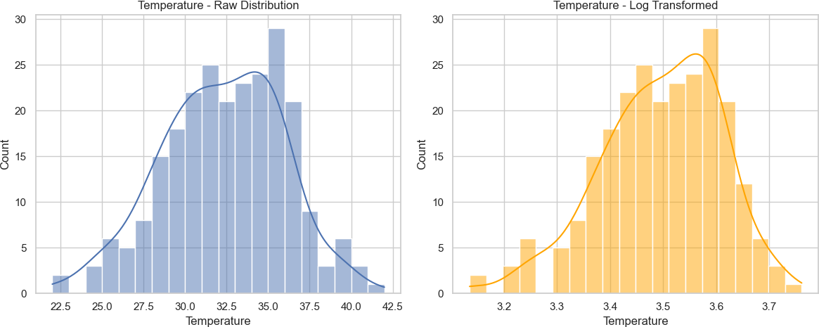

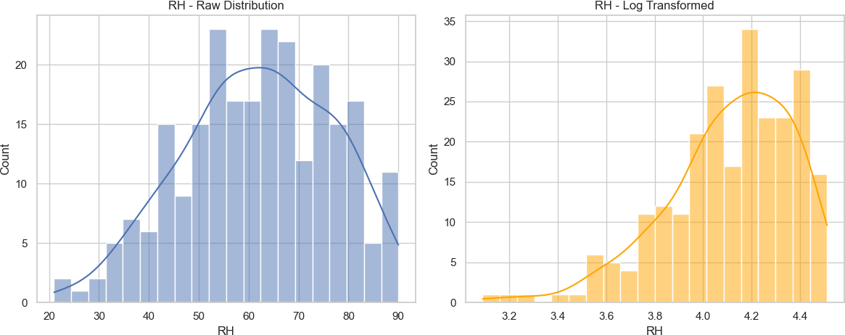

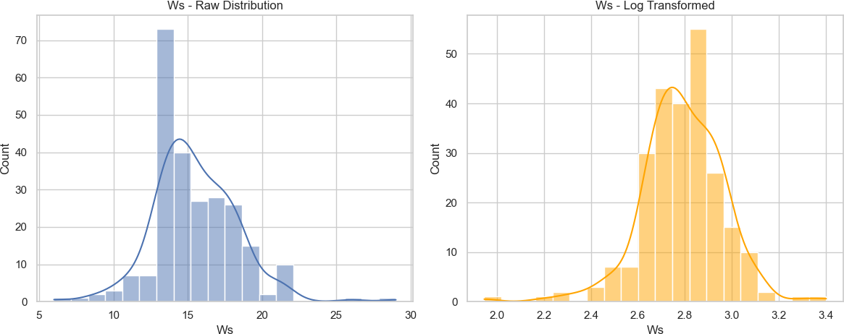

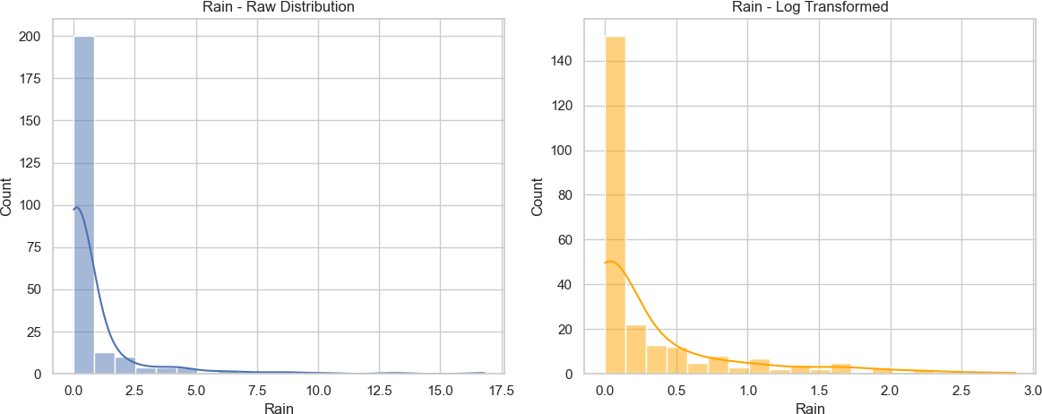

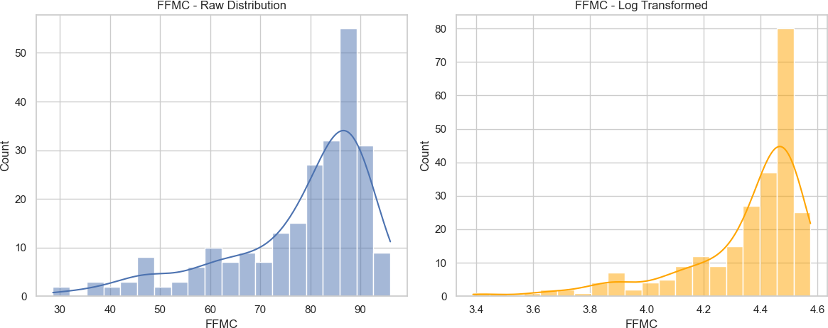

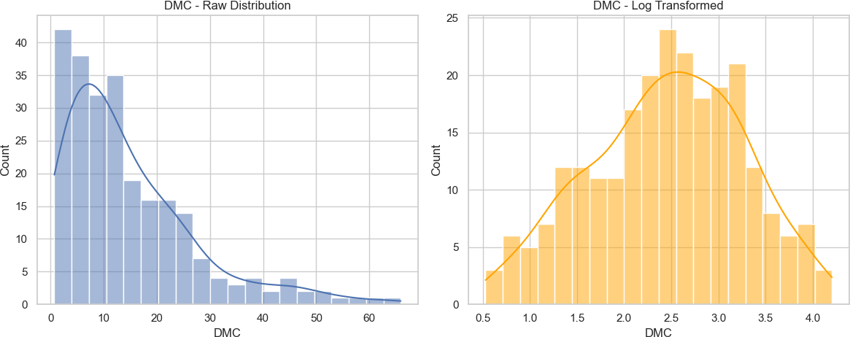

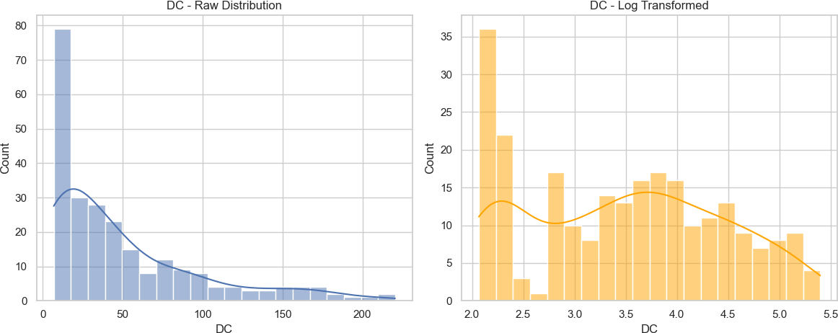

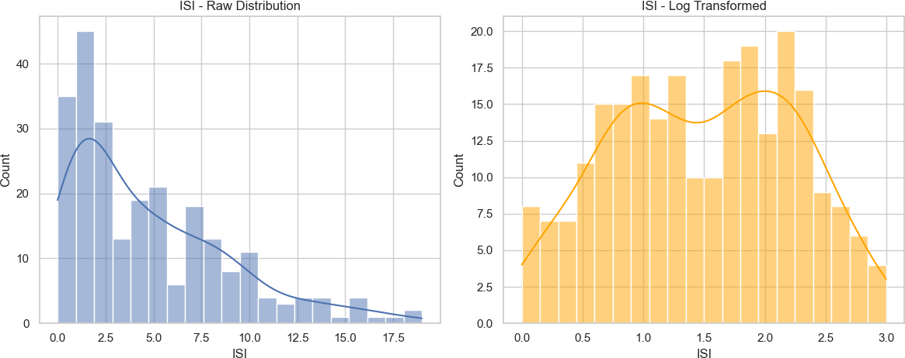

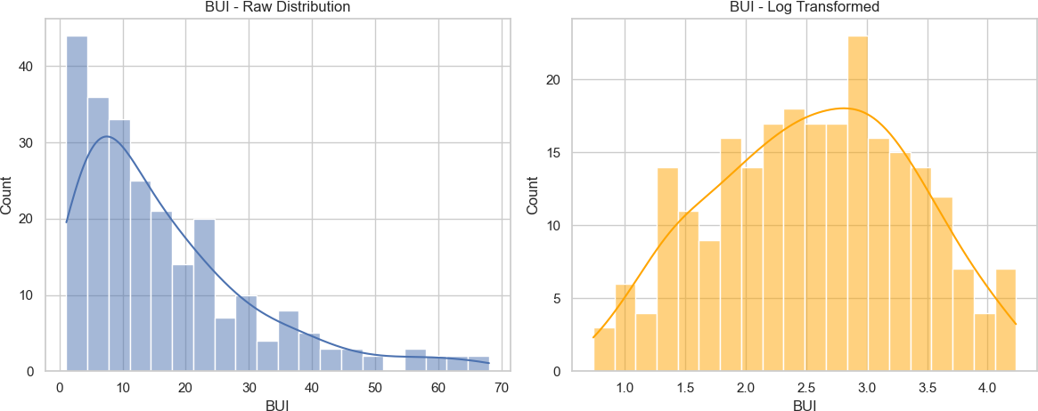

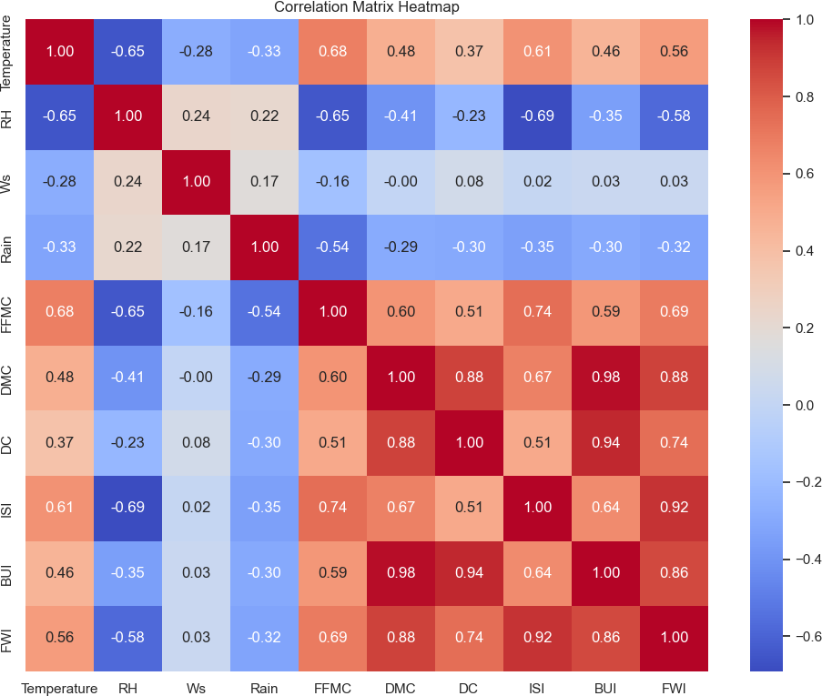

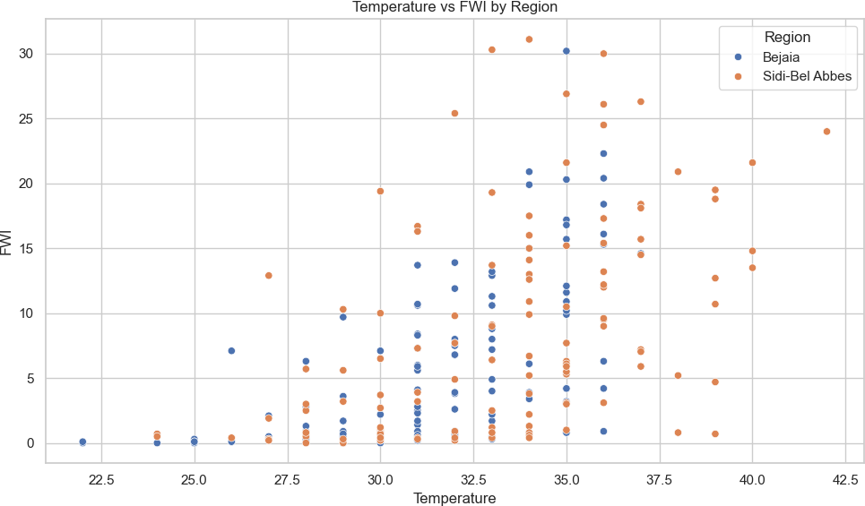

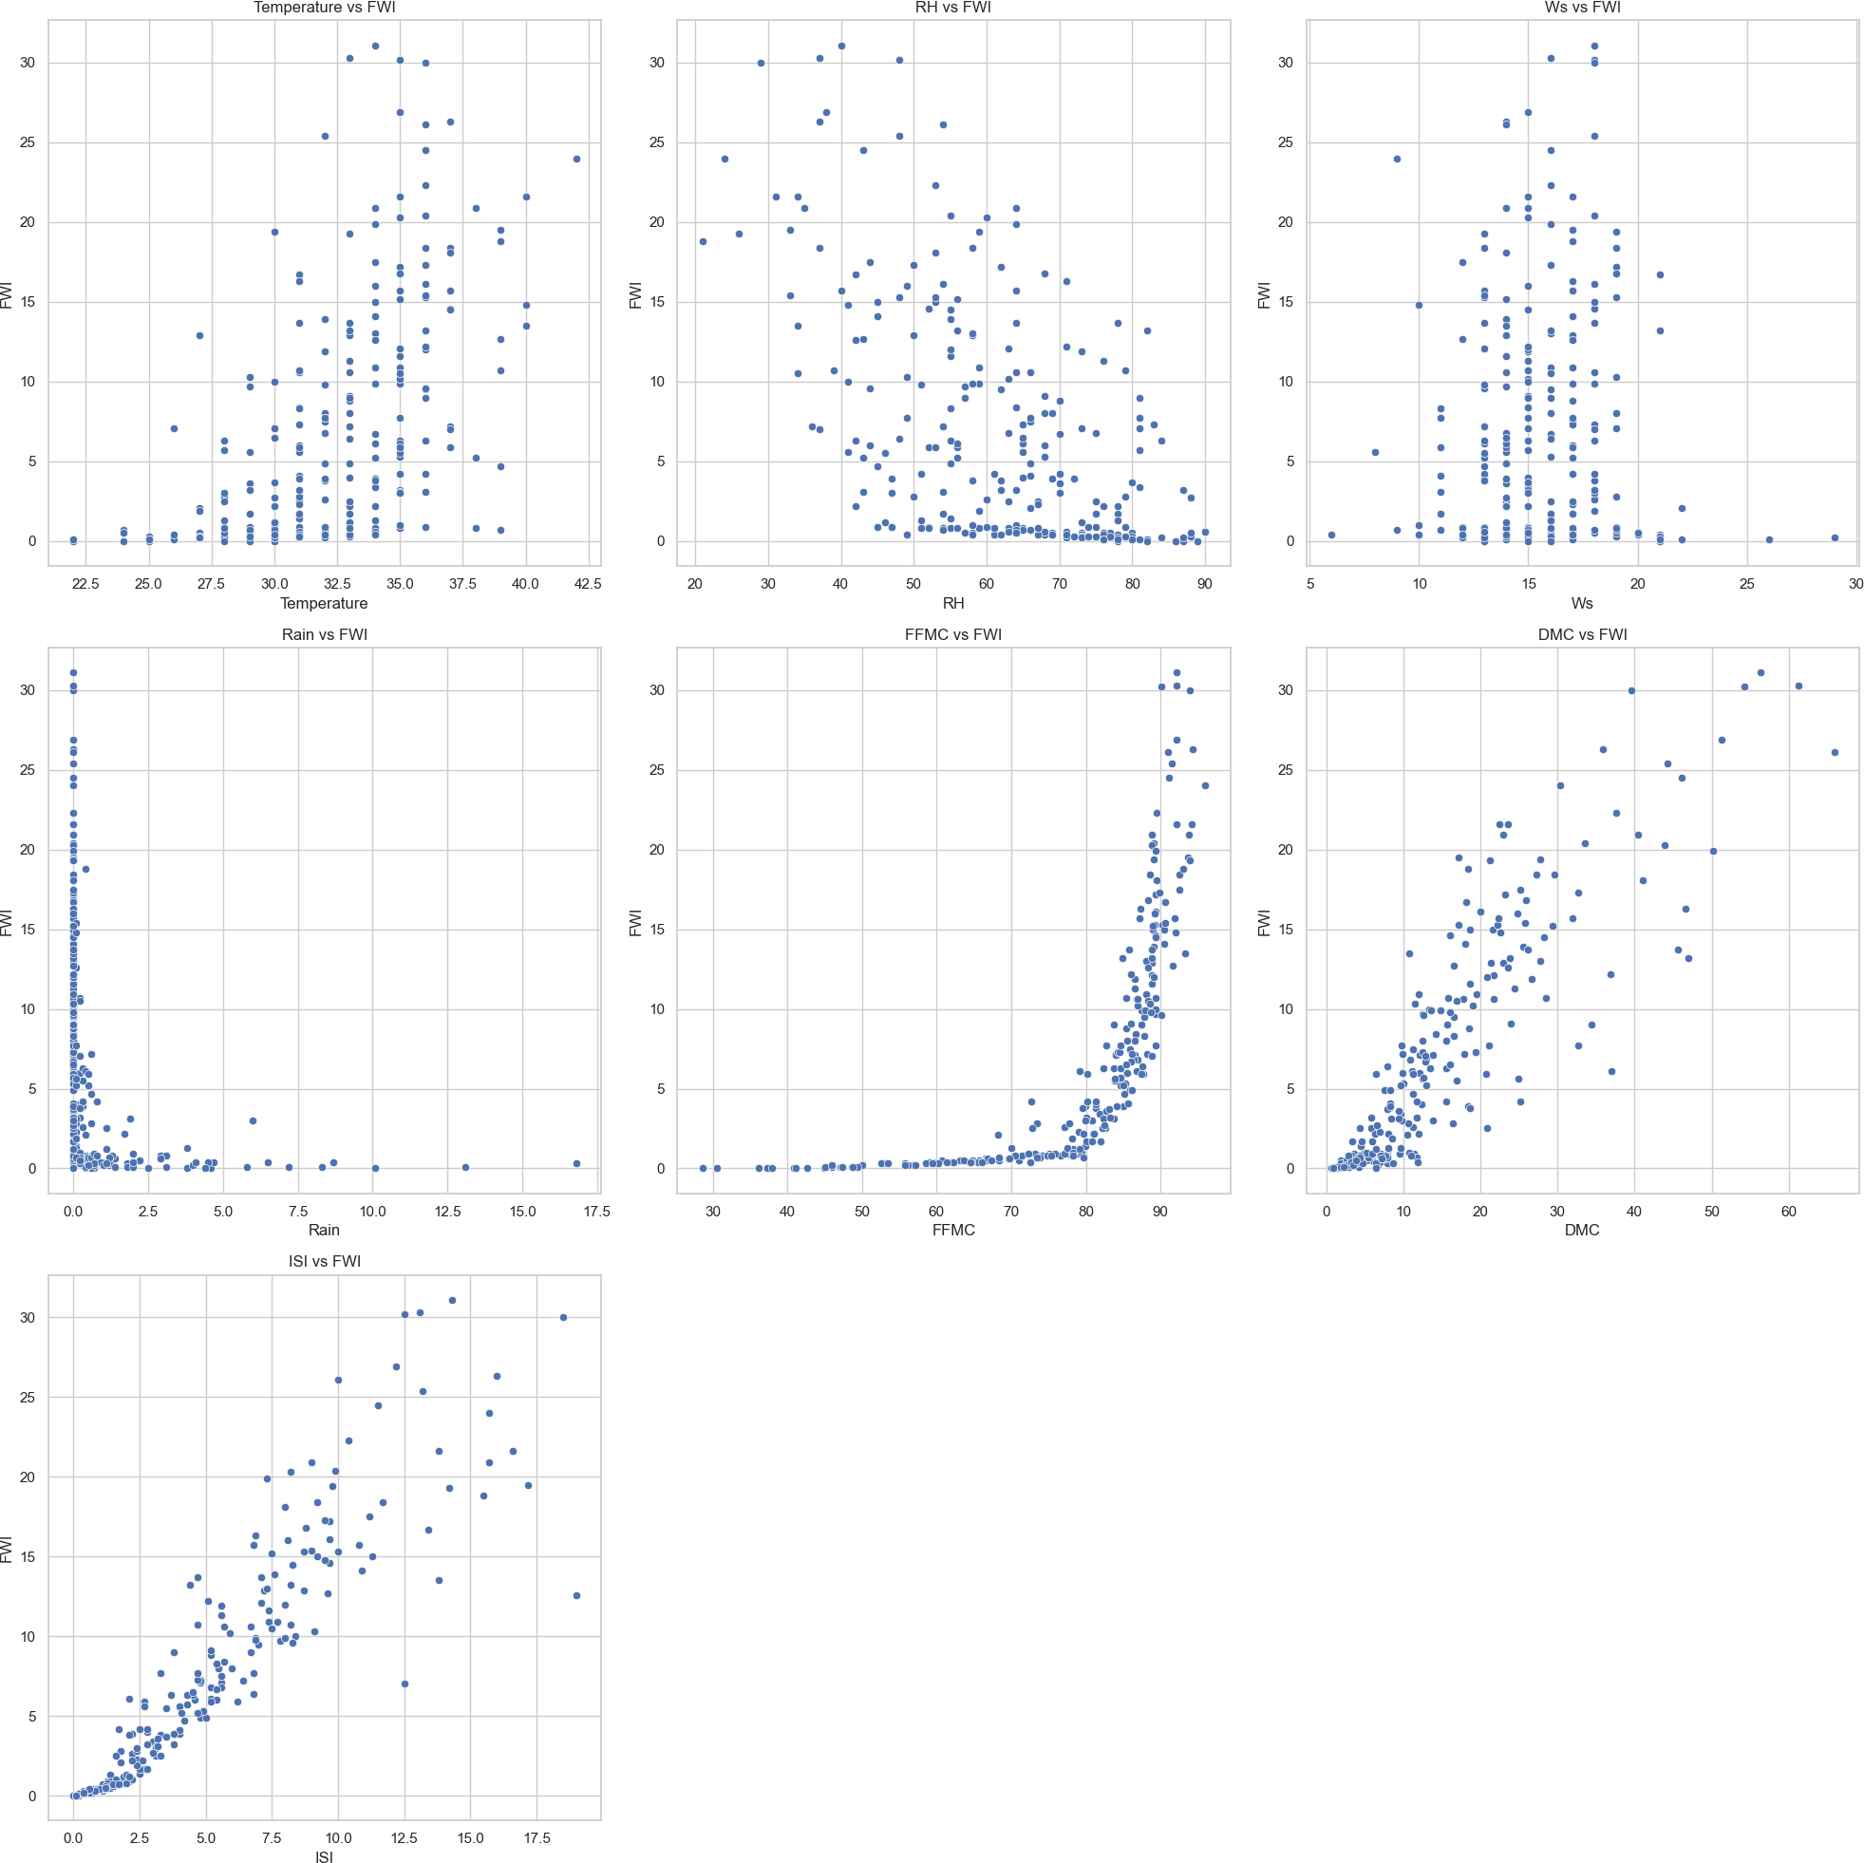

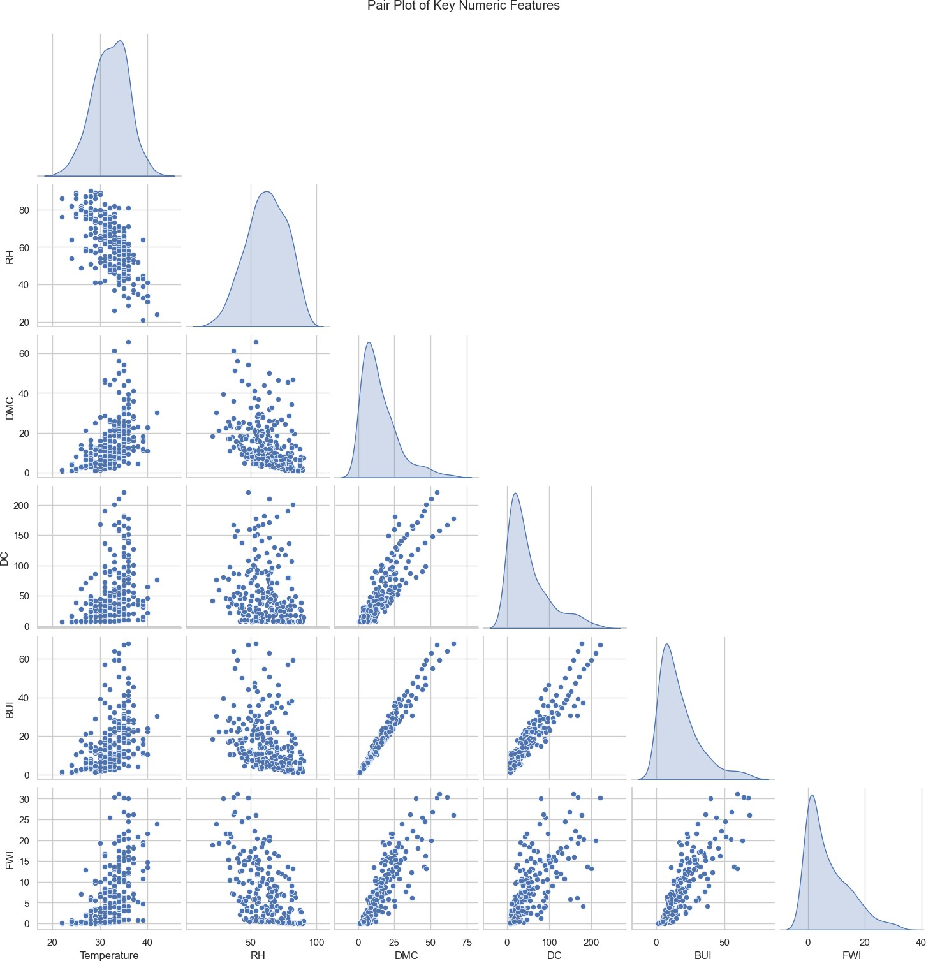

Execution Output

Output 1:
Random rows from the dataset:
day month year Temperature RH Ws Rain FFMC DMC DC ISI
191 9 8 2012 39 43 12 0.0 91.7 16.5 30.9 9.6
82 22 8 2012 36 55 18 0.0 89.1 33.5 151.3 9.9
149 28 6 2012 37 37 13 0.0 92.5 27.2 52.4 11.7
39 10 7 2012 33 69 13 0.7 66.6 6.0 9.3 1.1
4 5 6 2012 27 77 16 0.0 64.8 3.0 14.2 1.2
BUI FWI Classes Region
191 16.4 12.7 fire Sidi-Bel Abbes
82 43.1 20.4 fire Bejaia
149 27.1 18.4 fire Sidi-Bel Abbes
39 5.8 0.5 not fire Bejaia
4 3.9 0.5 not fire Bejaia

Output 2:
Rows containing missing values:
day month year Temperature RH Ws Rain FFMC DMC DC ISI
165 14 7 2012 37 37 18 0.2 88.9 12.9 14.6 9 12.5
BUI FWI Classes Region
165 10.4 fire NaN Sidi-Bel Abbes

Output 3:
DataFrame Information:
<class 'pandas.core.frame.DataFrame'> RangeIndex: 244 entries, 0 to 243 Data columns (total 15 columns):
# Column Non-Null Count Dtype
- day 244 non-null int64
- month 244 non-null int64
- year 244 non-null int64
- Temperature 244 non-null int64
- RH 244 non-null int64
- Ws 244 non-null int64
- Rain 244 non-null float64
- FFMC 244 non-null float64
- DMC 244 non-null float64
- DC 243 non-null float64
- ISI 244 non-null float64
- BUI 244 non-null float64
- FWI 243 non-null float64
- Classes 243 non-null object
- Region 244 non-null object
dtypes: float64(7), int64(6), object(2) memory usage: 28.7+ KB

Output 4–6:
Missing Values Handling Summary:
Missing Values BEFORE Handling: day 0
month 0
year 0
Temperature 0
RH 0
Ws 0
Rain 0
FFMC 0
DMC 0
DC 1
ISI 0
BUI 0
FWI 1
Classes 1
Region 0 dtype: int64
Missing Values AFTER Handling: day 0
month 0
year 0

Temperature 0
RH 0
Ws 0
Rain 0
FFMC 0
DMC 0
DC 0
ISI 0
BUI 0
FWI 0
Classes 0
Region 0 dtype: int64

Output 7:
Outlier Detection Using Boxplots and IQR: day: 0 outliers
month: 0 outliers
year: 0 outliers
Temperature: 2 outliers
RH: 0 outliers
Ws: 8 outliers
Rain: 35 outliers
FFMC: 16 outliers
DMC: 12 outliers
DC: 15 outliers
ISI: 4 outliers
BUI: 12 outliers
FWI: 4 outliers

Output 8:
FWI Correlation Summary: FWI 1.000000
ISI 0.916343
DMC 0.875827
BUI 0.857628
DC 0.739521
FFMC 0.690289
Temperature 0.564599
Ws 0.032315
Rain -0.324369
RH -0.577577

Output 9:
Data Types After Final Casting: FWI int64
DC int64 dtype: object

Module 3 – Feature Engineering & Scaling

-Computed correlation values between all features and the target variable FWI.

-Selected input features based on correlation strength (greater than 30%) while excluding day, month, year, and Region_encoded, and except Ws.

-Formed final feature set consisting of:
Temperature, RH, Ws, Rain, FFMC, DMC, DC, ISI, BUI

-Split dataset into feature matrix (X) and target variable (y).

-Applied StandardScaler to normalize numerical values for consistent scale.

-Converted scaled output to DataFrame to validate transformed distributions.

-Divided data into training and testing sets using train_test_split.

-Saved the scaler object as scaler.pkl for use during deployment and prediction.

import pandas as pd
import numpy as np
from sklearn.preprocessing import StandardScaler
from sklearn.model_selection import train_test_split
import pickle

df = pd.read_csv("../Dataset/FWI_Dataset_Final.csv")

# Compute correlation with FWI
corr_matrix = df.corr(numeric_only=True)
print("\nCorrelation Values with FWI:\n")
print(corr_matrix['FWI'].sort_values(ascending=False))

output

Correlation Values with FWI:

FWI 1.000000
ISI 0.919396
DMC 0.873823
BUI 0.855691
DC 0.737137
FFMC 0.696274
Temperature 0.568891
day 0.347711
Region_encoded 0.197913
month 0.086614
Ws 0.027030
Rain -0.328662
RH -0.581144
year NaN
Name: FWI, dtype: float64

# Selecting features based on > 30% correlation & rules:
# Keep Ws (manually kept)
selected_features = ['Temperature', 'RH', 'Ws', 'Rain', 'FFMC', 'DMC', 'DC', 'ISI', 'BUI']
target = 'FWI'
print("\nSelected Features for Model Training:\n", selected_features)

# Split X & y
X = df[selected_features]
y = df[target]

# Apply StandardScaler
scaler = StandardScaler()
X_scaled = scaler.fit_transform(X)

# Convert back to DataFrame for debugging
X_scaled_df = pd.DataFrame(X_scaled, columns=selected_features)

print("\nScaled Feature Summary:\n")
print(X_scaled_df.describe())

output

Scaled Feature Summary:

Temperature RH Ws Rain FFMC \
count 2.440000e+02 2.440000e+02 2.440000e+02 2.440000e+02 2.440000e+02
mean 8.444975e-16 -1.747236e-16 1.892839e-16 1.456030e-17 -6.260930e-16
std 1.002056e+00 1.002056e+00 1.002056e+00 1.002056e+00 1.002056e+00
min -2.805030e+00 -2.756122e+00 -3.388978e+00 -3.812229e-01 -3.444727e+00
25% -5.989790e-01 -6.690956e-01 -5.363325e-01 -3.812229e-01 -4.062510e-01
50% -4.746626e-02 7.146217e-02 -1.797518e-01 -3.812229e-01 3.922443e-01
75% 7.798029e-01 7.615274e-01 5.334097e-01 -1.306346e-01 7.277172e-01
max 2.710098e+00 1.889195e+00 4.812379e+00 8.038546e+00 1.265872e+00

DMC DC ISI BUI
count 2.440000e+02 2.440000e+02 2.440000e+02 2.440000e+02
mean -1.310427e-16 4.368091e-17 -2.184045e-16 -8.008166e-17
std 1.002056e+00 1.002056e+00 1.002056e+00 1.002056e+00
min -1.132118e+00 -8.932783e-01 -1.145779e+00 -1.097989e+00
25% -7.189175e-01 -7.668759e-01 -8.097864e-01 -7.523272e-01
50% -2.733089e-01 -3.455345e-01 -3.057969e-01 -3.114314e-01
75% 4.923278e-01 3.918130e-01 6.061841e-01 4.134012e-01
max 4.150370e+00 3.594008e+00 3.414126e+00 3.621359e+00

# Save Scaler
with open("scaler.pkl", "wb") as f:
pickle.dump(scaler, f)

print("\nScaler saved successfully as scaler.pkl")

# Train-test split
X_train, X_test, y_train, y_test = train_test_split(
X_scaled, y, test_size=0.2, random_state=42
)

print("\nTraining Shape:", X_train.shape)
print("Testing Shape:", X_test.shape)

output

Training Shape: (195, 9)
Testing Shape: (49, 9)

Module 4 – Model Training using Ridge Regression and Comparisons

Includes:

-Used Ridge Regression as the primary regression model due to its effectiveness in reducing multicollinearity and stabilizing coefficients.

-Trained a total of five models for comparative analysis:

-Ridge Regression (primary)

-Linear Regression

-Lasso Regression

-Decision Tree Regressor

-Random Forest Regressor

-Applied mean imputation to handle any remaining null values before model training.

-Evaluated performance of all models using:

-Root Mean Squared Error (RMSE)

-R-Squared (R²) score

-Saved the Ridge model as ridge.pkl using pickle for deployment consistency.

-Compared model results to identify the best performer based on lowest RMSE and highest R² score.

-Ridge Regression achieved strong predictive performance and is selected as the deployed model.

from sklearn.metrics import mean_squared_error, r2_score
from sklearn.impute import SimpleImputer

# Impute missing values if any
imputer = SimpleImputer(strategy='mean')
X_train = imputer.fit_transform(X_train)
X_test = imputer.transform(X_test)

results = {}

# Ridge Regression (primary model)
from sklearn.linear_model import Ridge
ridge = Ridge(alpha=1.0)
ridge.fit(X_train, y_train)
ridge_pred = ridge.predict(X_test)
results["Ridge"] = (
np.sqrt(mean_squared_error(y_test, ridge_pred)),
r2_score(y_test, ridge_pred)
)
with open("ridge.pkl", "wb") as f:
pickle.dump(ridge, f)
print("\nRidge Regression Saved as ridge.pkl")

# Linear Regression
from sklearn.linear_model import LinearRegression
lr = LinearRegression()
lr.fit(X_train, y_train)
lr_pred = lr.predict(X_test)
results["Linear Regression"] = (
np.sqrt(mean_squared_error(y_test, lr_pred)),
r2_score(y_test, lr_pred)
)

# Lasso Regression
from sklearn.linear_model import Lasso
lasso = Lasso(alpha=0.1)
lasso.fit(X_train, y_train)
lasso_pred = lasso.predict(X_test)
results["Lasso"] = (
np.sqrt(mean_squared_error(y_test, lasso_pred)),
r2_score(y_test, lasso_pred)
)

# Decision Tree
from sklearn.tree import DecisionTreeRegressor
dt = DecisionTreeRegressor(max_depth=5, random_state=42)
dt.fit(X_train, y_train)
dt_pred = dt.predict(X_test)
results["Decision Tree"] = (
np.sqrt(mean_squared_error(y_test, dt_pred)),
r2_score(y_test, dt_pred)
)

# Random Forest
from sklearn.ensemble import RandomForestRegressor
rf = RandomForestRegressor(n_estimators=120, max_depth=5, random_state=42)
rf.fit(X_train, y_train)
rf_pred = rf.predict(X_test)
results["Random Forest"] = (
np.sqrt(mean_squared_error(y_test, rf_pred)),
r2_score(y_test, rf_pred)
)

for model, (rmse, r2) in results.items():
print(f"{model} → RMSE: {rmse:.4f}, R²: {r2:.4f}")

output

Ridge → RMSE: 0.6614, R²: 0.9889
Linear Regression → RMSE: 0.6501, R²: 0.9892
Lasso → RMSE: 0.7903, R²: 0.9841
Decision Tree → RMSE: 1.4128, R²: 0.9491
Random Forest → RMSE: 0.8211, R²: 0.9828

Milestone-3
Module-5: Evaluation & Optimization

Step-1: Load Required Libraries

import numpy as np
import matplotlib.pyplot as plt
from sklearn.metrics import mean_absolute_error, mean_squared_error, r2_score
from sklearn.linear_model import Ridge
from sklearn.model_selection import GridSearchCV

This loads tools required for:
- Error calculation
- Visualization
- Model tuning

Step-2: Perform Hyperparameter Tuning using GridSearchCV

param_grid = {'alpha': [0.01, 0.1, 1, 10, 100]}

ridge = Ridge()
grid = GridSearchCV(ridge, param_grid, cv=5, scoring='r2')
grid.fit(X_train, y_train)

print("Best Alpha:", grid.best_params_)
print("Best CV R²:", grid.best_score_)

output:

Best Alpha: {'alpha': 1}
Best CV R²: 0.95426153800731

GridSearchCV tested different values of alpha and found that:
α = 1 gives the best cross-validated performance
This ensures:
- Overfitting is controlled
- Model generalizes well

Step-3: Train Final Ridge Model Using Best Alpha

best_alpha = 1
ridge_final = Ridge(alpha=best_alpha)
ridge_final.fit(X_train, y_train)

This retrains Ridge using the optimized alpha value

Step-4: Predict on Train & Test Data

y_train_pred = ridge_final.predict(X_train)
y_test_pred = ridge_final.predict(X_test)

Step-5: Compute Evaluation Metrics

train_r2 = r2_score(y_train, y_train_pred)
test_r2 = r2_score(y_test, y_test_pred)

rmse = np.sqrt(mean_squared_error(y_test, y_test_pred))
mae = mean_absolute_error(y_test, y_test_pred)

print("Train R²:", train_r2)
print("Test R² :", test_r2)
print("Test RMSE:", rmse)
print("Test MAE:", mae)

Output
Train R²: 0.96945
Test R² : 0.98885
Test RMSE: 0.66139
Test MAE: 0.50958

This proves the model is not overfitting.

Step-6: Predicted vs Actual Plot

plt.figure(figsize=(6,6))
plt.scatter(y_test, y_test_pred)
plt.plot([y_test.min(), y_test.max()], [y_test.min(), y_test.max()], 'r')
plt.xlabel("Actual FWI")
plt.ylabel("Predicted FWI")
plt.title("Actual vs Predicted FWI")
plt.show()

- Points close to red line = accurate prediction
- Your plot showed near-perfect alignment → high model quality

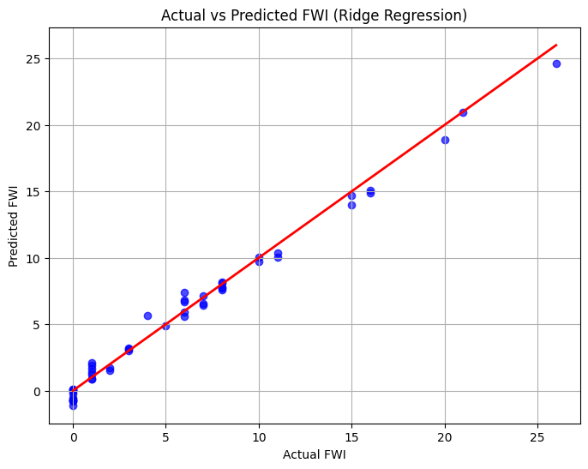

Step-7: Residual Plot

residuals = y_test - y_test_pred

plt.figure(figsize=(6,4))
plt.scatter(y_test_pred, residuals)
plt.axhline(0, color='r')
plt.xlabel("Predicted FWI")
plt.ylabel("Residuals")
plt.title("Residual Plot")
plt.show()

Residuals randomly scattered around 0 →
1.No bias
2.Good fit

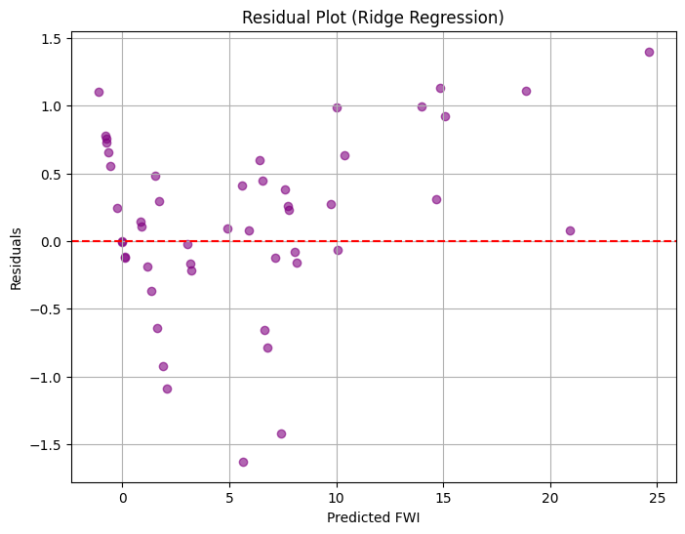

Step-8: Train vs Test Accuracy Plot

plt.figure(figsize=(6,4))
plt.bar(["Train R²", "Test R²"], [train_r2, test_r2])
plt.ylim(0,1)
plt.title("Train vs Test Accuracy")
plt.show()
Your plot showed both above 0.96 — excellent generalization.

Step-8: Train vs Test Accuracy Plot

plt.figure(figsize=(6,4))
plt.bar(["Train R²", "Test R²"], [train_r2, test_r2])
plt.ylim(0,1)
plt.title("Train vs Test Accuracy")
plt.show()

plot showed both above 0.96 — excellent generalization.

